WBIRS – Steps to Execute

1. In Eclipse IDE, Select *File* 🡪 *Import*.

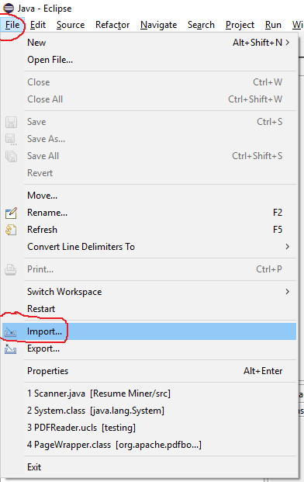

1. A Import dialogue box will open, Under *General*, ‘*Select Existing Project into Workspace*’ and press ‘*Next*’

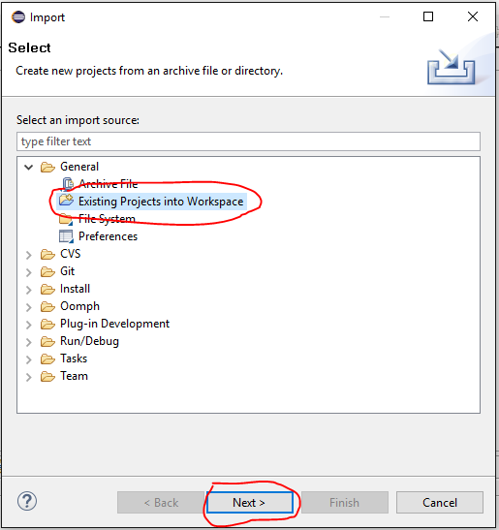

1. In the next Import Dialogue box, Click on ‘*Browse’* and select the location of the ‘*Resume Miner folder’* and click on ‘*Finish’.*

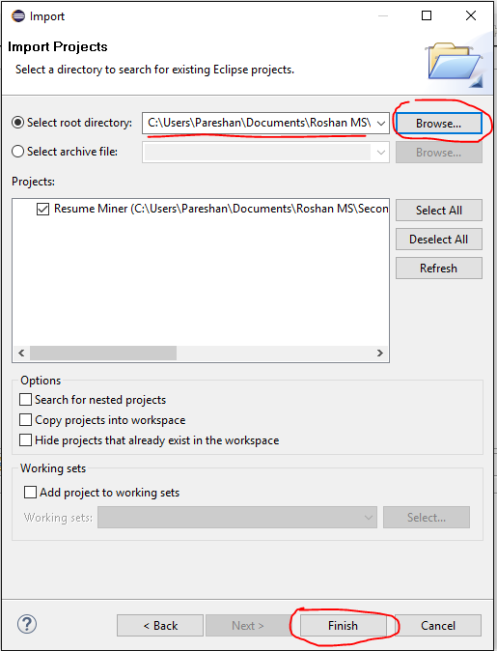

1. After Import is done, Under ‘*Package Explorer’* 🡪 Expand ‘*Resume Miner’ 🡪 Expand ‘Src’ 🡪 Expand ‘(default package)’ 🡪 Double Click on ‘Scanner.java’*

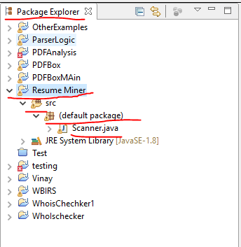

1. Enter a directory path for the data store variable and a filename( full path) for the indexFile variable as shown below (lines 22 and 23):



1. Make sure the paths are correct in the previous stage and press Run to execute the program.